**ASSIGNMENT – 8**

**Problem Statement:** Deploy a project from Local Machine to GitHub and vice-versa.

**Procedure:**

**Step 1:** Make sure you have installed Git for Windows Application if you are using a Windows machine. If not then download. You have to integrate it with the Windows Shell.

Now go to GitHub Website and Sign in to your account. If you do not have account then click on Sign Up button to Create an account.



**Step 2:** After successfully signing in GitHub, click on the ‘+’ button situated on the top right corner of the website beside your profile picture. Now after clicking a menu will appear. Click on New Repository. This will create a New Repository where you can upload/deploy your project folders and files.

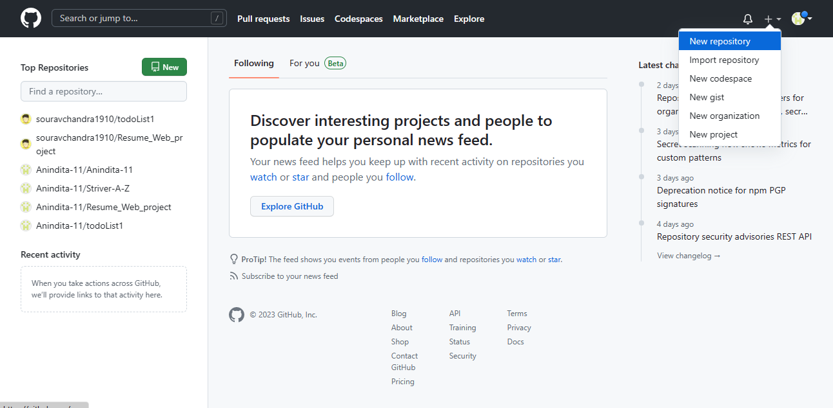

**Step 3:** Now Enter the name of the Repository. Select the Private option below and click on Create Repository.

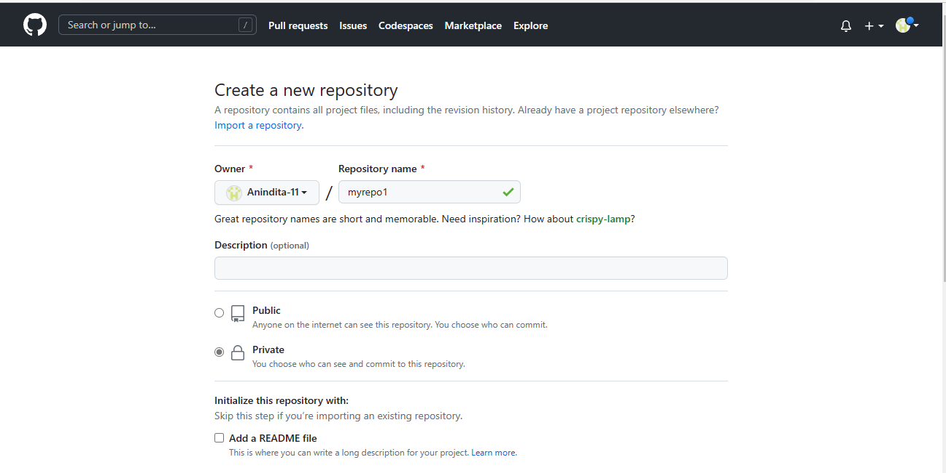

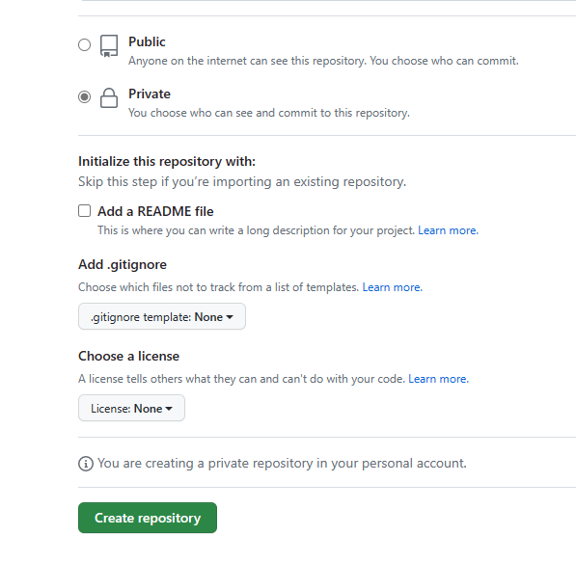

**Step 4:** You will be redirected to the Repository code page. Now while adding your project to your GitHub repository, you need to use Token generated for your account.

For generating token for your account follow the steps:

* + Click on your profile on the top right corner of the web page.
  + A drop-down menu will appear. Click on the Settings option.

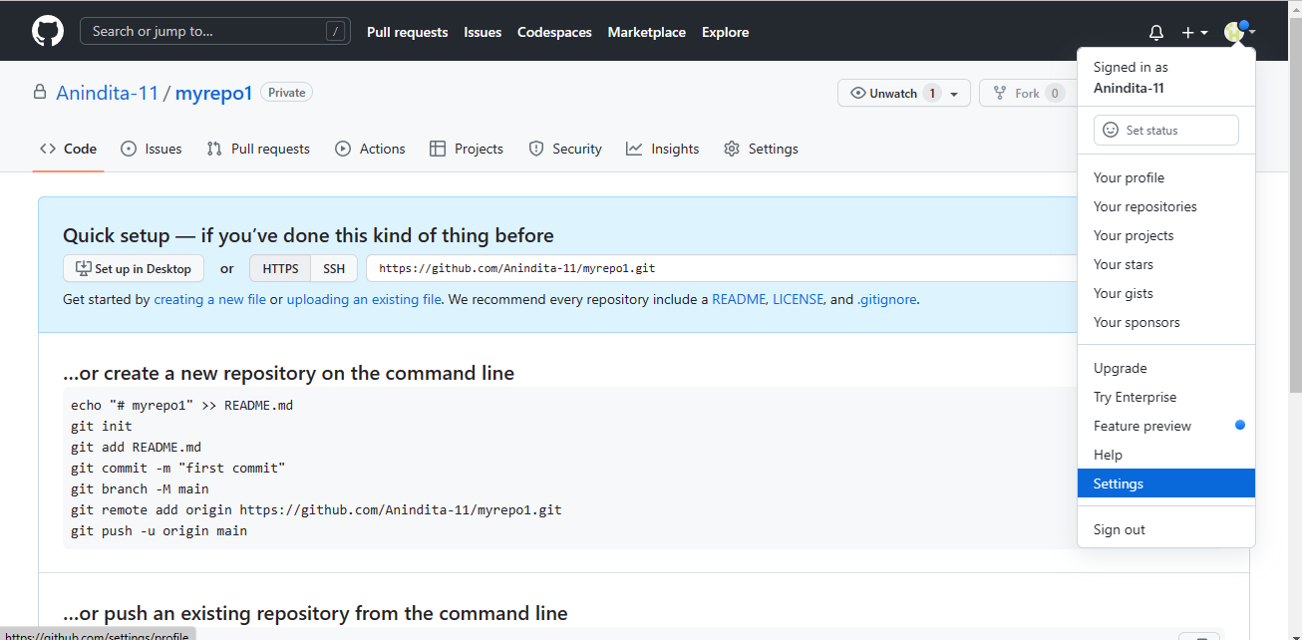

**Step 5:** Now scroll down and click on the Developer settings on the left Nav bar.

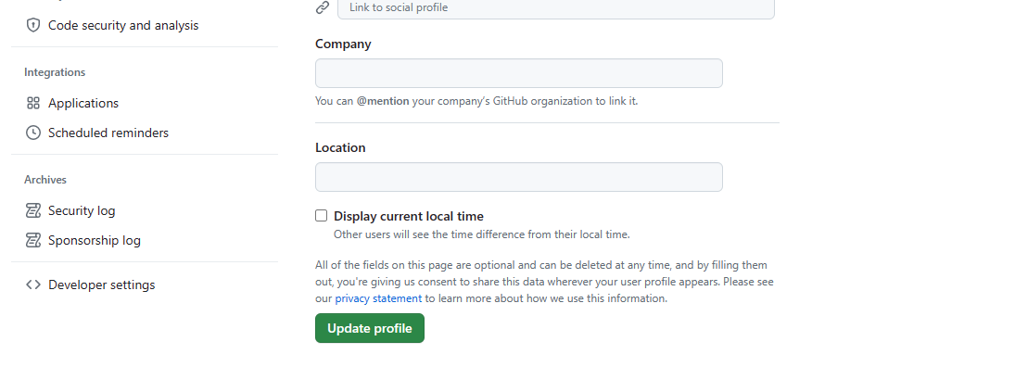

**Step 6:** Click on the Down arrow beside Personal Access Tokens in the left Nav bar.

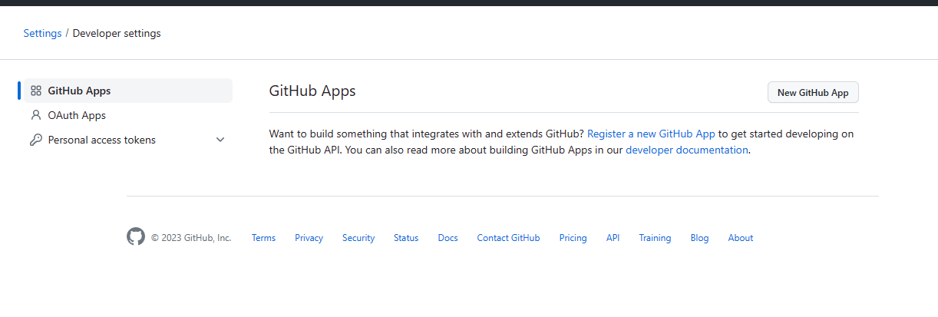

**Step 7:** Next click on the Tokens(classic) option.

* 1. 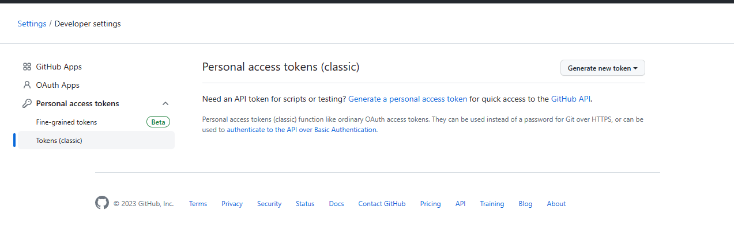
  2. **Step 8:** Next click on Generate New Token button **.**

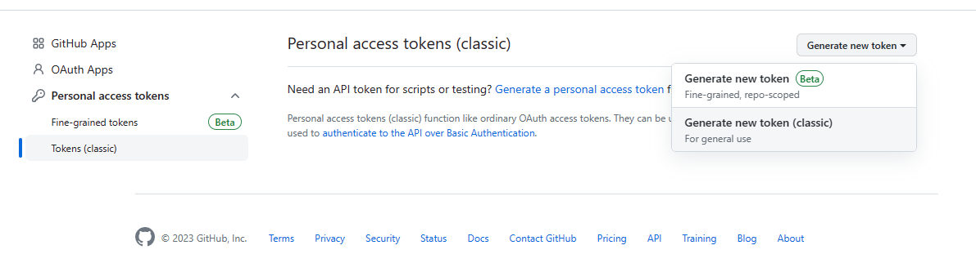

**Step 9**: Again, click on Generate New Token(classic).

* Give the Token Name.
* Select the Expiration time (Preferably 90 Days).
* Now check all the parent boxes below.

Then Click on Generate Token Button.

* 1. 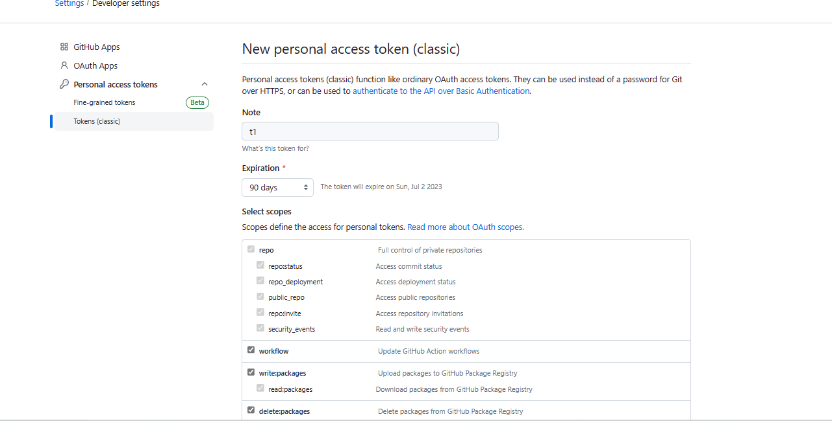
  2. 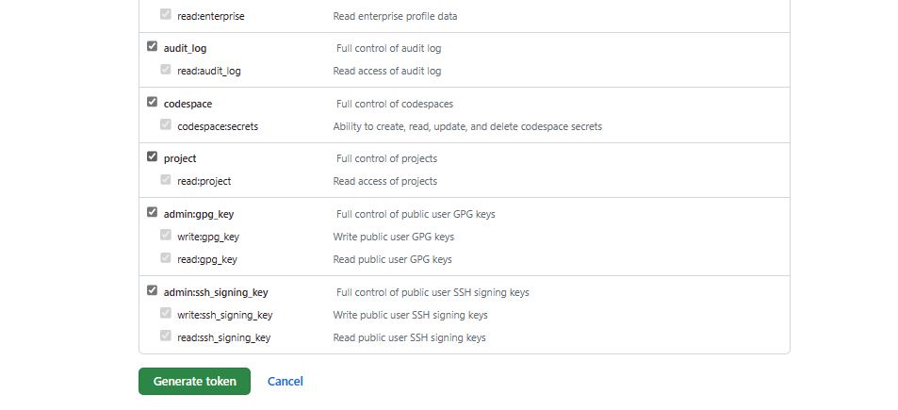

Now a Token will be generated. Copy it and save it in a text file. Keep it somewhere safe as we will need it later.

**Step 10:** scroll-up and click on the icon on the top left corner of the web page (looking like a cat). This will redirect you to your home page.

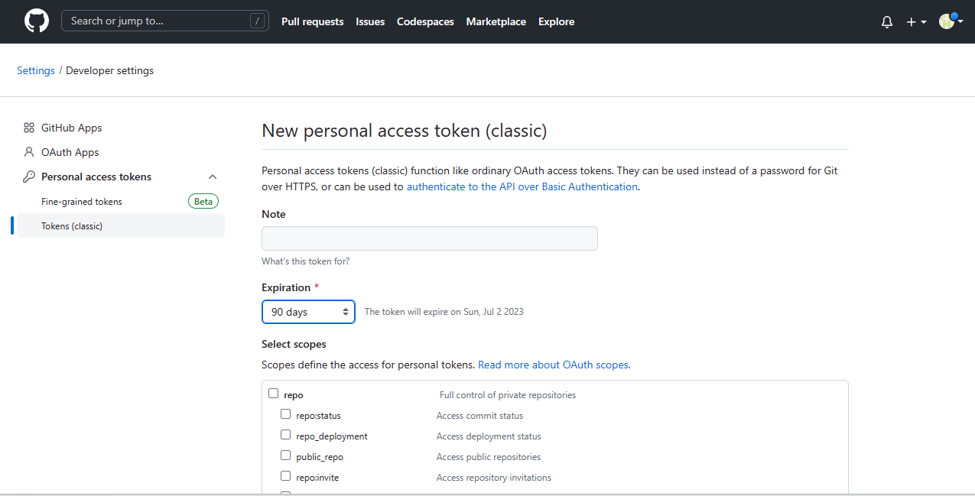

**Step 11:** On the left nav bar you will find your Top Repositories You are currently working/contributing to. You can also locate your newly created Repository here.

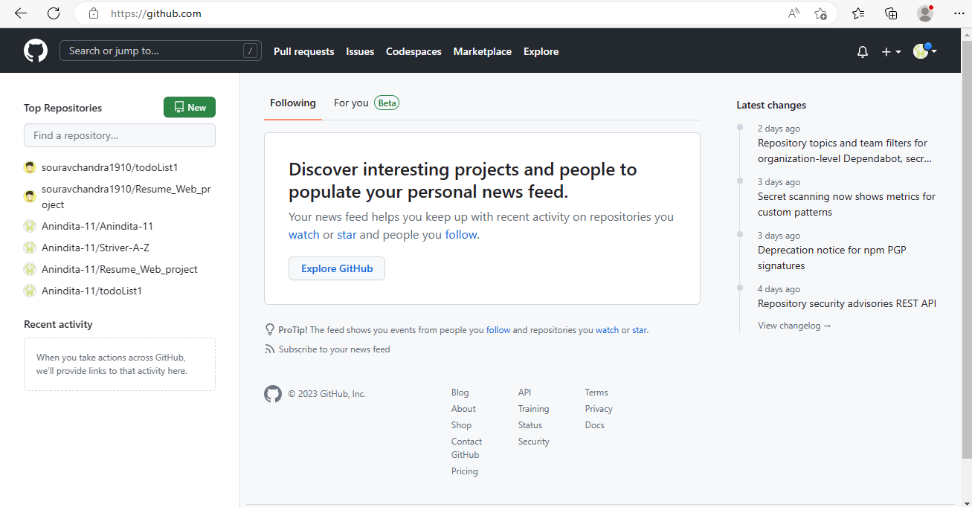

**Step 12:** Go to the code section and keep it open. Now minimize your browser. Now create a folder anywhere in your computer. Give it a name. Now Right Click on it and select Git Bash here. It will open the Git Bash Terminal.



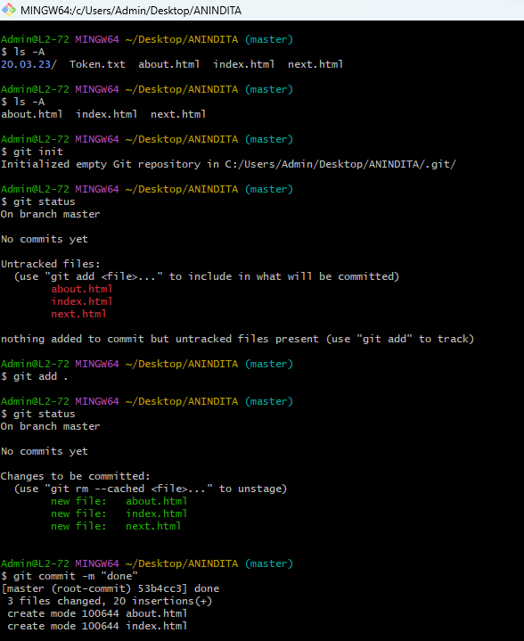



**Step 13:** Now type the following to clone the project provided/required.

* **git init**



* **git clone** <https://github.com/sudip7407/New-Repo1.git>

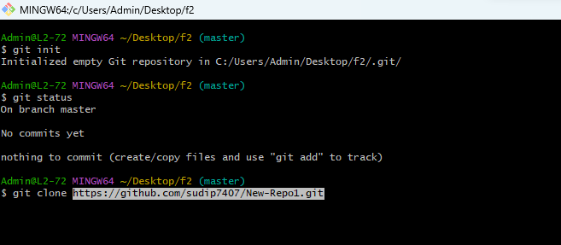

* **ls -A**

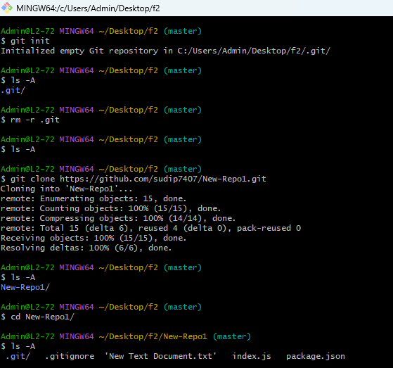

We see all the files downloaded from the repository we just cloned. Now we have to remove the **.git/** files from all the folders. Also, we have to remove. gitignore files from wherever it is present.

* **rm -r .git**

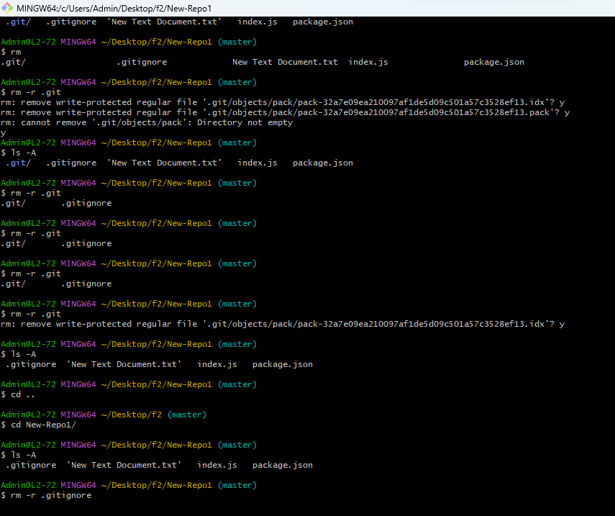

We have successfully removed the .git/ file from the main directory.

* **cd New-Repo1**



(Sometimes permissions are asked when removing some files. Just type y when prompted and press enter and repeat it when asked every time.)

* **rm -r .git**



* **rm -r .gitignore**
* **ls -A**

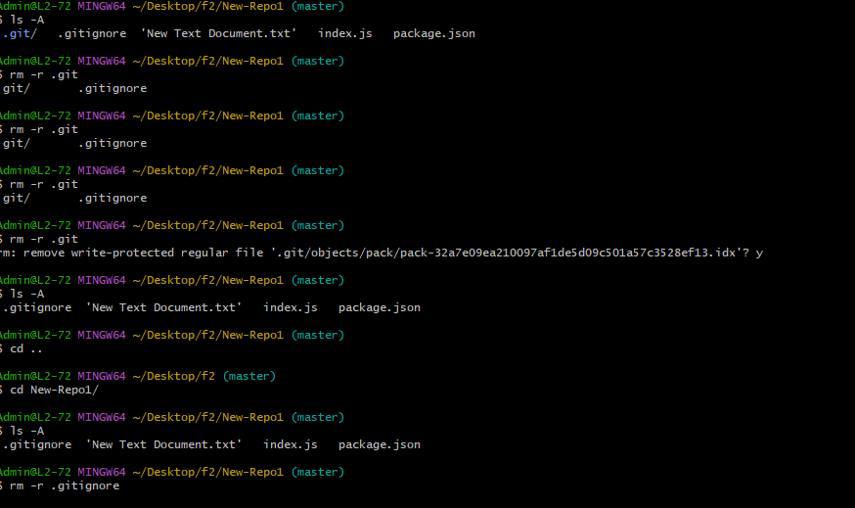

We have done our main work and now we will back to our main directory.

* **cd ..**





**Step 14:** Now close the terminal and open the folder in which you just cloned the project. Single Click on the New-Repo1 file and right click and just like explained above again select Git bash here option.

**Step 15:** Again, a Git bash terminal will open. Again, type the following commands but now we will now upload this cloned project to our created repository on our GitHub:

* **git init**
* **ls -A**
* **git status**

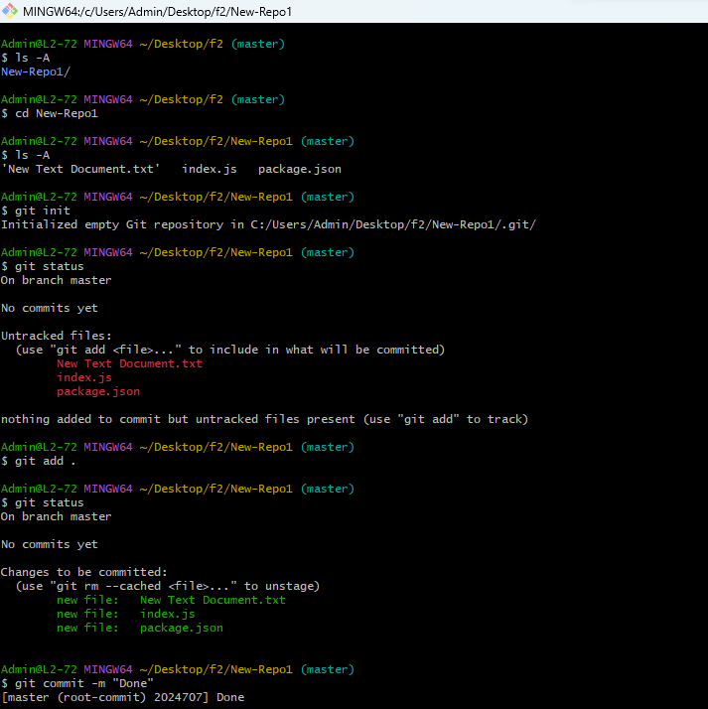

* **git config --global user.email “Your email here”**
* **git config --global user.name “Your GitHub account username here”**
* **git config user.name**
* **git config user.email**

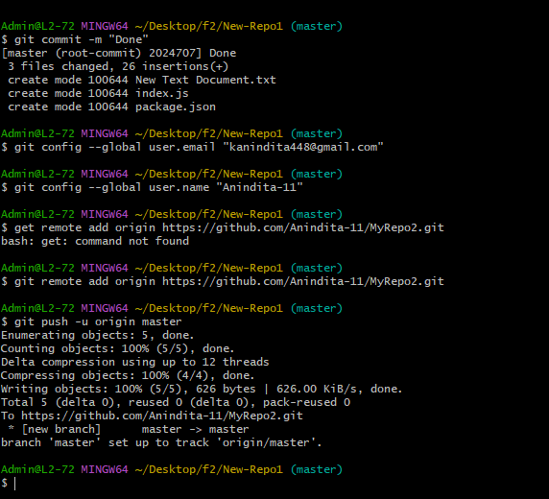

* **git add .**
* **git status**



* **git commit -m “type a message here”**



* git remote addorigin **‘address of your repository ’**

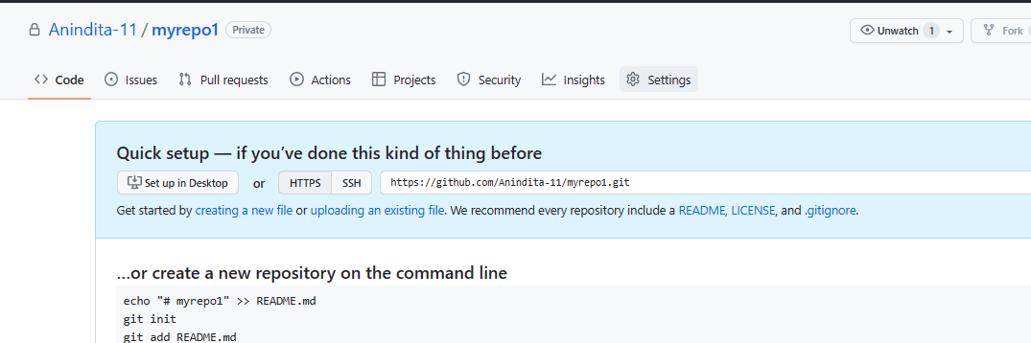

* **git push -u origin master**

After this command a pop-up window will open named Connect to GitHub.

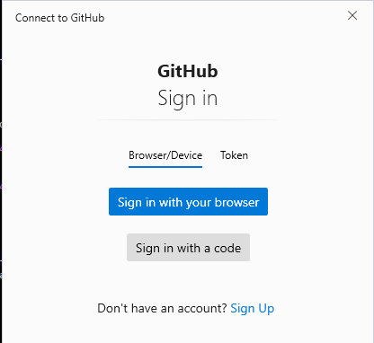

**Step 16:** Now go to your browser where your GitHub repository is open. Refresh the page. Now you will see the files uploaded in your repository**.**

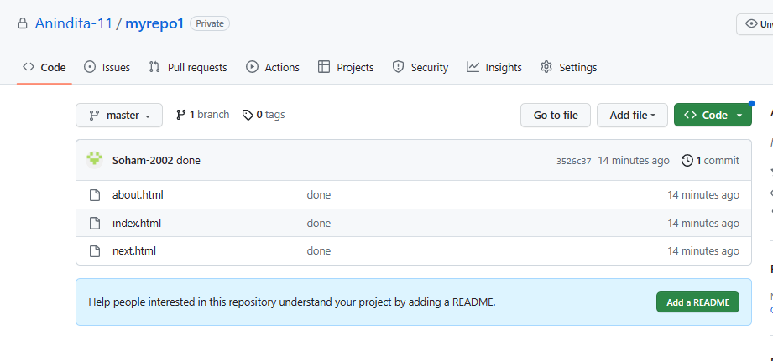

**We have successfully Cloned and Uploaded our project to GitHub using Git and Git Bash terminal.**

**Step 17:** You can also add collaborators who can access your private repository and can contribute to it.

* Go to the Setting section of your repository
* Then select the collaborators option in the left nav bar. It will ask you to enter your password.
  1. 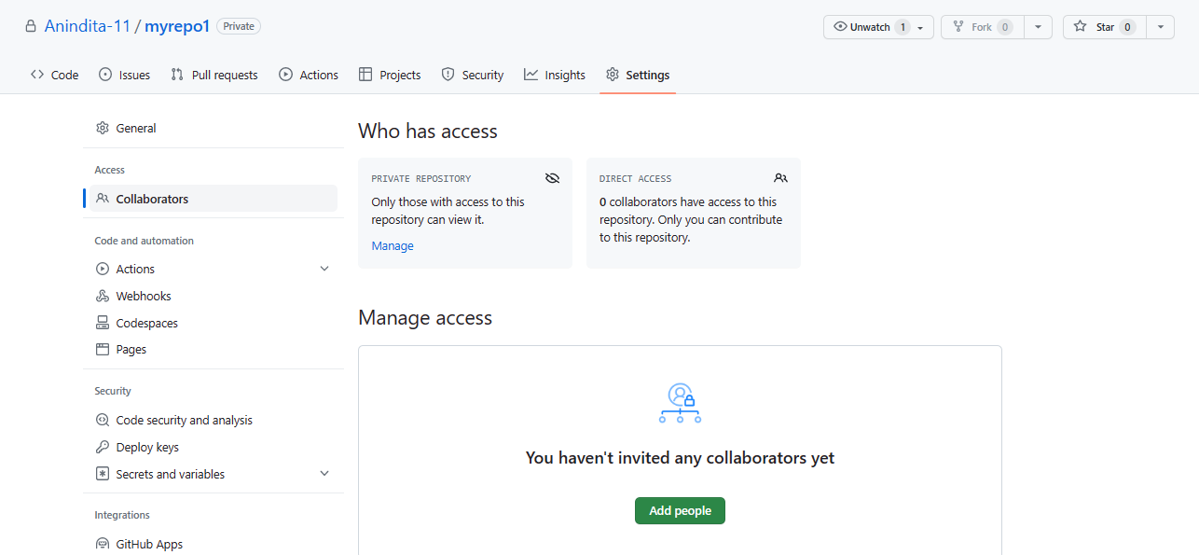
  + Now you can click on add people button to add others as collaborators of your repository. You have to search by their Username or Email.

